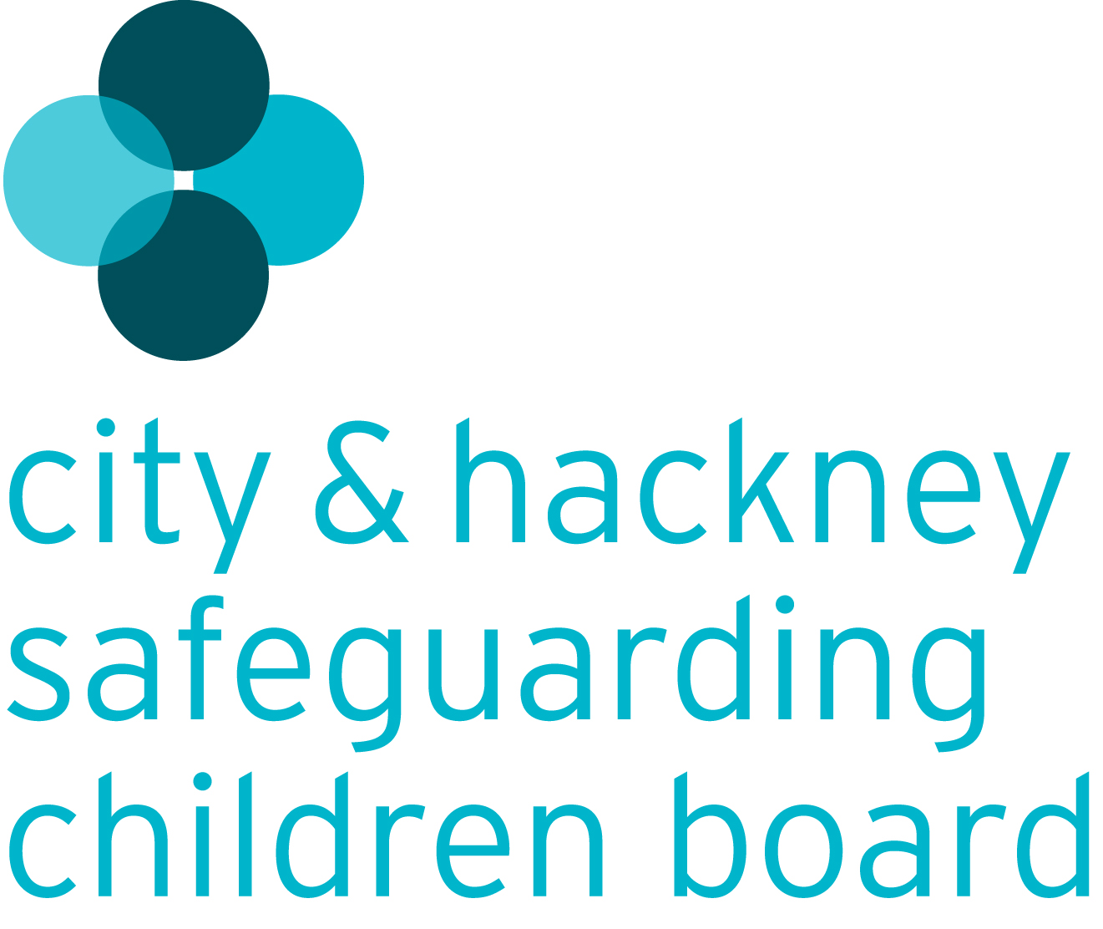

Inter-Board Protocol

The relationship between:

- The City of London Health & Wellbeing Board
- The Safety City Partnership
- The City & Hackney Safeguarding Children Board
- The City & Hackney Safeguarding Adults Partnership Board

April 2016
Name | Organisation/Designation | Signature
Jim Gamble | City and Hackney Safeguarding Children Board, Independent Chair | 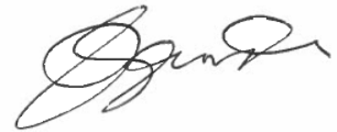
Deputy Pollard | Chair of Safer City Partnership | 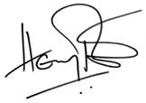
Joyce Nash | Deputy Chair of the City Health and Wellbeing Board | 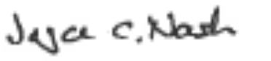
Dr Adi Cooper | Chair of the City and Hackney Safeguarding Adult’s Board

Contents Page

Introduction 3
Principles 3

Board Functions 3-4
The City Health and Wellbeing Board

The City Safer Partnership

The City & Hackney Safeguarding Children Board

The City & Hackney Safeguarding Adults Board

Communication & Engagement 4-5

Practical Arrangements to Secure Coordination 5

Appendix 1: The Four Board 7

Appendix 2: Board responsibilities and Functions 8-10

1. Introduction

1.1 The aim of this protocol is to define how the City of London Health and Wellbeing Board (CHWB) and the Safety City Partnership (SCP) work together with the City & Hackney Safeguarding Children Board (CHSCB) and the City & Hackney Safeguarding Adults Board (CHSAB) in the pursuit of safeguarding and promoting the health and wellbeing of children, young people and adults.

1.2 This protocol sets out the principles underpinning how the four Boards work across their defined remits, the specific function of each Board, how communication and engagement will be secured across the Boards and the practical means by which effective co-ordination and coherence between the Boards will be secured. The protocol also refers to the interface with other partnership forums in Hackney.

1.3 The role of the CHSCB and CHSAB in relation to the CHWB and the SCP is one of equal partners underpinned by this protocol.

2. Principles

2.1 This protocol does not seek to dilute the discreet responsibilities of each Board. Its focus is on ensuring that the following simple principles underpin how the four Boards will operate.

- Safeguarding is the business of all Boards
- The Boards will know each other’s business
- A culture of scrutiny and challenge will exist across the Boards
- The Boards will work together to avoid duplication and ensure consistency

3. Board Functions

3.1 The City of London Health and Wellbeing Board

3.2 Health and Wellbeing Boards were established by the Health and Social Care Act 2012. They are a forum where key leaders from the health and care system work together to improve the health and wellbeing of their local population and reduce health inequalities.

3.3 Board members collaborate to understand their local community’s needs, agree priorities and encourage commissioners to work in a more joined up way. As a result, patients and the public should experience more joined-up services from the NHS and local councils.

3.4 The Safety City Partnership

3.5 Community Safety Partnerships are made up of representatives from the police, local authorities, fire and rescue authorities, probation service and health.

3.6 The SCP ensures agencies work together to protect their local communities from crime and to help people feel safer. They work out how to deal with local issues like antisocial behaviour, drug or alcohol misuse and re-offending. The SCP annually assesses local crime priorities and consults partners and the local community about how to deal with them.

3.7 The City & Hackney Safeguarding Children Board

3.8 The CHSCB is the key statutory body for agreeing how organisations co-operate to safeguard and promote the welfare of children and young people in City and Hackney, and for ensuring the effectiveness of what they do.

3.9 The CHSCB is made up of a Board with senior representatives from its member agencies and various sub-committees which undertake the Board’s business.

3.10 The City & Hackney Safeguarding Adults Board

3.11 The CHSAB is a multi-agency partnership which has statutory functions under the Care Act 2014. The main objective of the board is to assure itself that local safeguarding arrangements and partners act to safeguard adults at risk of abuse in the local area.

4. Communication and Engagement

4.1 Everyone has a responsibility for safeguarding.

4.2 As such, all key strategic plans whether they be formulated by individual agencies or by partnership forums should include safeguarding as a cross-cutting theme to ensure that existing strategies and service delivery, as well as emerging plans for change and improvement include effective safeguarding arrangements that ensure that all people in the City of London are safe and their wellbeing is protected.

4.3 The Health and Wellbeing Strategy for the City of London is a key commissioning strategy for the delivery of services to children and adults.

4.4 The SCP produces an annual strategic assessment on community safety to inform the SCP Strategy. This document allows the SCP to make informed decisions about partnership priorities and target setting.

4.5 It is critical that in drawing up, delivering and evaluating both strategies there is effective interchange between the CHWB and the SCP with the two Safeguarding Boards.

4.6 Specifically there need to be formal interfaces with the Safeguarding Boards at key points including:

- The needs analyses that drives the formulation of the annual Health and Wellbeing Strategy, the SCP Strategy and the Safeguarding Boards’ Business Plans. This needs to be reciprocal in nature ensuring that the Safeguarding Boards’ needs analyses are fed into the Joint Strategic Needs Assessment (JSNA) and strategic assessment for the SCP and that the outcomes of the JSNA and SCP strategic assessment are fed back into Safeguarding Boards’ planning;

- Ensuring each Board is regularly updated on progress made in the implementation of the Health and Wellbeing Strategy, the SCP Strategy and the individual Board business plans in a context of mutual scrutiny and challenge;

- Annually reporting evaluations of performance on plans to provide the opportunity for reciprocal scrutiny and challenge and to enable all Boards to feed any improvement and development needs into the planning process for future years’ strategies and plans.

4.7 The opportunities presented by a formal working relationship between the CHWB, the SCP, the CHSCB and the CHSAB can be summarised as follows:

- Securing an integrated approach to the JSNA and SCP strategic analysis, ensuring comprehensive safeguarding data is included in both (consistent with the statutory guidance contained within Working Together 2013)

- Aligning the work of the CHSCB and CHSAB business plans with the HWB Strategy, and SCP Strategy and related priority setting.

- Ensuring safeguarding is everyone’s responsibility, reflected in the public health agenda and related determinant of health strategies; together with community safety priorities and the short, medium and long term objectives of the SCP.

- Evaluating the impact of the HWB Strategy and SCP Strategy on safeguarding outcomes, and of safeguarding on wider determinants of health and community safety outcomes.

- Identifying coordinated approach to communication, learning and improvement, performance management, change and commissioning

- Cross Board scrutiny and challenge and ‘’holding to account’’: the CHWB and SCP for embedding safeguarding, and the Safeguarding Boards for overall performance and contribution to the HWB and SCP Strategies.

5. Practical Arrangements to Secure Co-ordination

5.1 The following arrangements detail the effective co-ordination and coherence in the work of the three Boards.

  - Bi-Annually, the chairs of the 4 Boards will meet to ensure the coordination of leadership, the coherence of respective plans and to consider the strategic risks facing children, young people, families, adults and communities. These meetings will take place in April/May and September/October.

5.3 Between September and November each year, the Independent Chairs of the two Safeguarding Boards will present to the Health & Wellbeing Board and the Safety City Partnership Board their Annual Reports outlining performance against Business Plan objectives in the previous financial year.

5.4 This will be supplemented by a position statement on the Boards’ performance in the current financial year.

5.5 This will provide the opportunity for the Health and Wellbeing Board and the Safety City Partnership Board to scrutinise and challenge the performance of the Boards, to draw across data to be included in the JSNA and SCP strategic analysis and to reflect on key issues that may need to be incorporated in the refresh of the Health and Wellbeing Strategy and the SCP Strategy.

5.6 Between October and February, the City of London Health & Wellbeing Board and the Safety City Partnership Board will present to the Safeguarding Boards the review of their respective strategies including the refreshed JSNA and SCP analysis and the proposed priorities and objectives for each.

5.7 This will enable the Safeguarding Boards to scrutinise and challenge performance and to ensure that the refreshed Safeguarding business plans appropriately reflect relevant priorities set by the CHWB and the SCP.

5.8 In April / May the Boards will share their refreshed plans for the coming financial year to ensure co-ordination and coherence.

5.9 In addition to the scheduled interface across all four Boards, it is expected that relevant learning arising from reviews is shared; and opportunities for coordinating consultations, communications and engagement are fully utilized.

6. Relationships between the Safeguarding Boards

6.1 There should be equally effective co-ordination and coherence between the two safeguarding boards. This will be achieved in part by the arrangements set out above but it is critical that there are processes in place to ensure effective cross-working, scrutiny and challenge. This will be achieved in two ways:

- Sharing annual plans during the formulation stages to enable co-ordination and coherence where there are overlaps in business.
- Ensuring that there is cross-Board representation to secure on-going communication.

Appendix 1: The Four Boards

City of London Health & Wellbeing Board
Strategic Vision / Direction / Objectives / Outcome Setting and Oversight
CHSCB
Scrutiny & challenge / oversight of practice, protection and safeguarding children outcomes (including early help)
CHSAB
Scrutiny & challenge / oversight of practice, protection and safeguarding adult outcomes (including early help)
Safety City Partnership
Strategic Vision / Direction / Objectives / Outcome Setting and Oversight

Shared Priorities
Strategic Risks
Shared Learning – lessons from reviews
Shared Consultation
Joint Communication & Engagement

Appendix 2: Board Responsibilities and Functions

What the City of London Health and Wellbeing Board does

The Health and Wellbeing Board aims to improve the health and wellbeing of local people and tackle health inequalities by:

- identifying local health needs and priorities, and making sure commissioning plans reflect the findings of our analysis of local health needs, the Joint Strategic Needs Assessment (JSNA). In the City, this document is known as the City and Hackney Health and Wellbeing Profile.
- preparing and publishing a Joint Health and Wellbeing Strategy based upon the needs identified within the JSNA. It will help us plan the delivery of integrated local services by addressing the underlying factors of health and wellbeing.
- encouraging agencies to collaborate
- communicating and engaging with the public and other stakeholders about how to achieve the best possible quality of life
- assessing needs for pharmaceutical services in the City of London and publishing a Pharmaceutical Needs Assessment (PNA). The Health and Wellbeing Board must produce its first assessment of pharmaceutical needs by 1 April 2015.

Health and Wellbeing Boards have strategic influence over commissioning decisions across health, public health and social care through the development of a Health and Wellbeing strategy.

Boards are intended to strengthen democratic legitimacy by involving democratically elected representatives and patient representatives in commissioning decisions alongside commissioners across health and social care. The boards also provide a forum for challenge, discussion, and the involvement of local people.

Boards will bring together clinical commissioning groups and councils to develop a shared understanding of the health and wellbeing needs of the community.

They will undertake the Joint Strategic Needs Assessment (JSNA) and develop a joint strategy for how these needs can be best addressed. This will include recommendations for joint commissioning and integrating services across health and care.

Through undertaking the JSNA, the board will drive local commissioning of health care, social care and public health and create a more effective and responsive local health and care system. Other services that impact on health and wellbeing such as safeguarding, housing and education provision will also be addressed.

What the Safety City Partnership does

The Safer City Partnership is accountable for the following key statutory responsibilities which must be met:

- a strategy group to be made up of senior representatives from the responsible authorities
- prepare, implement and performance manage an evidence-led annual strategic assessment and three-yearly partnership plan for the reduction of crime and disorder in the area
- consult the community on the levels and patterns of crime, disorder and substance misuse and on matters that need to be prioritised by the partnership
- reduce re-offending
- coordinate domestic violence homicide reviews
- share information among the responsible authorities within the SCP
- have a crime and disorder scrutiny committee with the power to review and scrutinise decisions made and action taken by the community safety partnership
- assess value for money of partnership activities.

What the City and Hackney Safeguarding Children Board does

The key objectives of the CHSCB, as set out in the statutory guidance, ‘Working Together to Safeguard Children’ 2013, are:

- To co-ordinate local work to safeguard and promote the wellbeing of children;
- To ensure the effectiveness of that work

Regulation 5 of the Local Safeguarding Children Boards Regulations 2006 sets out that the functions of the LSCB, in relation to the above objectives under section 14 of the Children Act 2004, are as follows:

1(a) developing policies and procedures for safeguarding and promoting the welfare of children in the area of the authority, including policies and procedures in relation to:

(i) the action to be taken where there are concerns about a child’s safety or welfare, including thresholds for intervention;
(ii) training of persons who work with children or in services affecting the safety and welfare of children;
(iii) recruitment and supervision of persons who work with children;
(iv) investigation of allegations concerning persons who work with children;
(v) safety and welfare of children who are privately fostered;
(vi) cooperation with neighbouring children’s services authorities and their Board partners;

(b) communicating to persons and bodies in the area of the authority the need to safeguard and promote the welfare of children, raising their awareness of how this can best be done and encouraging them to do so;

(c) monitoring and evaluating the effectiveness of what is done by the authority and their Board partners individually and collectively to safeguard and promote the welfare of children and advising them on ways to improve;

(d) participating in the planning of services for children in the area of the authority; and

(e) undertaking reviews of serious cases and advising the authority and their Board partners on lessons to be learned.

Regulation 5 (3) provides that an LSCB may also engage in any other activity that facilitates, or is conducive to, the achievement of its objectives.

What the City and Hackney Safeguarding Adult Board does

The CHSAB has three main duties under the Care Act:

It must publish a strategic plan for each financial year that sets how it will meet its main objective and what the members will do to achieve this. The plan must be developed with local community involvement, and the SAB must consult the local Healthwatch organisation. The plan should be evidence-based and make use of all available evidence and intelligence from partners to form and develop its plan.

It must publish an annual report detailing what the SAB has done during the year to achieve its main objective and implement its strategic plan, and what each member has done to implement the strategy as well as detailing the findings of any safeguarding adults reviews and subsequent action.

It must conduct any safeguarding adults review in accordance with Section 44 of the Act. In order to meet these objectives the board acts as follows:

- agrees and reviews multi-agency City and Hackney safeguarding adults policy and procedure for protecting vulnerable adults, taking into account statutory requirements, national guidance and London regional policies
- maintains an annual business plan, setting priorities for preventing and addressing abuse of vulnerable adults, and produces and disseminates an annual report
- monitors incidents of abuse and neglect, reviews trends and acts where appropriate to improve services and support to vulnerable adults
- regularly evaluates how agencies and providers safeguard vulnerable adults, by introducing rigorous quality assurance and scrutiny systems across partner agencies
- agrees a serious case review protocol and reviews and learns from situations where safeguarding arrangements may have been inadequate
- maintains a programme of training and development on safeguarding vulnerable adults for staff across agencies in the statutory, independent provider and voluntary sectors
- develops and promotes arrangements for adults at risk and carers to be well-informed about safeguarding arrangements and provide opportunities for service users and carers to influence and feedback on their effectiveness
- promotes public awareness of safeguarding as an issue for all citizens and engage the wider community in helping to prevent abuse and neglect and to report where they have concerns

