Introduction

Firstly, thank you for taking the time to complete the audit tool on behalf of your school for the City and Hackney Safeguarding Children Board (CHSCB). We are very pleased that your school is taking its safeguarding responsibilities seriously and undertaking the audit.

We carry out audits in order to monitor the effectiveness safeguarding children arrangements in the City and Hackney. Schools and Governing Bodies have a statutory obligation to ensure safeguarding arrangements are in place under Sections 157 and 175 of the Education Act 2002.

The findings from the audits will enable the CHSCB to understand more greatly where the needs and gaps are in safeguarding children. We believe it is also a good opportunity to present your progress in improving safeguarding arrangements and sharing examples of good practice.

Further Support

If you still have questions, please do not hesitate to contact:

Sandra Reid, Business and Performance Manager
Email: sandra.reid@hackney.gov.uk
Tel: 020 8356 4175

Copies of the audit tool should be returned in electronic format where possible.

Please note – pictures are for illustration only – you may notice slight differences in the current version of the tool.

Getting started

- The audit is to be completed on the audit tool template – it is an Excel spreadsheet.

- When you open up the template, you will see there are different tabs on the bottom of the spreadsheet.

- Click on ‘Introduction’ to fill in the key details for your school – school name, audit name, email address etc. The audit should be signed off by the Head Teacher / Academy Lead and the audit/action plan shared with the whole Governing Body.

Filling in the audit

- The audit is split into different worksheets. Under the ‘Introduction’ page you will see a breakdown of the worksheets.

- You can either click through to the worksheets on this page or you can navigate to the worksheets by clicking on the numbers at the bottom of the spreadsheet.

- Here is an example below of how you fill in the first worksheet. The first worksheet focuses on the standard ‘Senior leadership commitment to the importance of safeguarding and promoting children’s welfare’
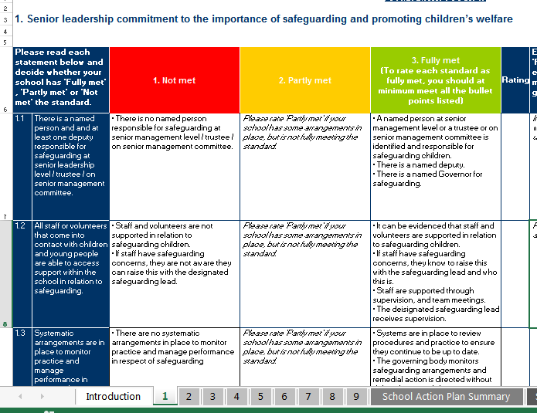

Read statement and think about whether your school is not meeting, partly meeting or fully meeting this statement.
This column gives you an explanation of ‘not meeting’ the statement.

This column is left blank for ‘partly meeting’ the statement. You may want to rate ‘partly met’ if your school has some measures in place but not quite fully meeting the statement.
This column gives you an explanation of ‘fully meeting’ the statement.

Click on the drop-down box to rate your school’s score. If you change your decision, highlight the box and click ‘Delete’ to make it blank again.

- Important! When you have rated your scores, you need to provide further details. Your audit tool will be returned if this is not completed!
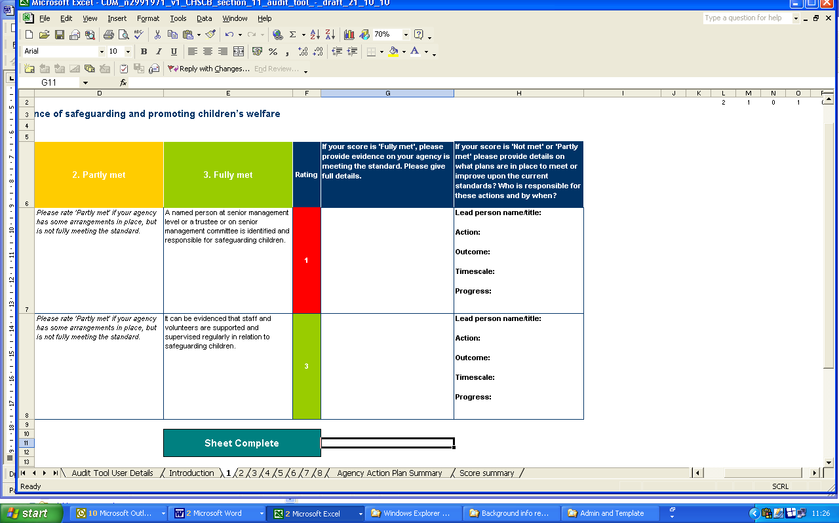
The rating for this statement is ‘not met’ – so you need to provide details on how your school plans to make improvements. You should identify a lead person, recommend action, desired outcome, give timescale and monitor progress in this box.
The rating for this statement is ‘fully met’ – so you need to provide full details on how your school is meeting the standard. You may see prompts or questions in italics – please include this in your response!

- You need to complete all of the worksheets in this way. Once you have completed the work sheets, the spreadsheet will generate an action plan summary from your responses in on the worksheets. Click on ‘School Action Plan Summary’ tab.

- The action plan summary will look like this:

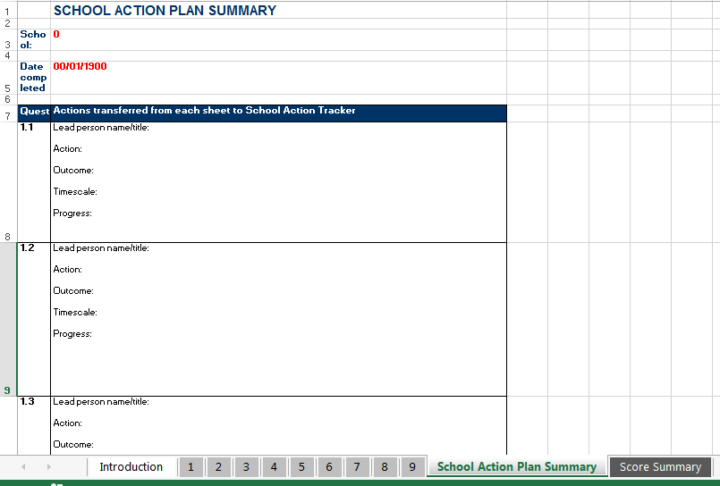

The spreadsheet will transfer the comments from the worksheets into these boxes, so you are able to look at all your school’s actions in one place.

- Once you have completed the work sheets, the spreadsheet will also generate a score summary. Click on ‘Score Summary’ tab.

- The score summary will look like this:

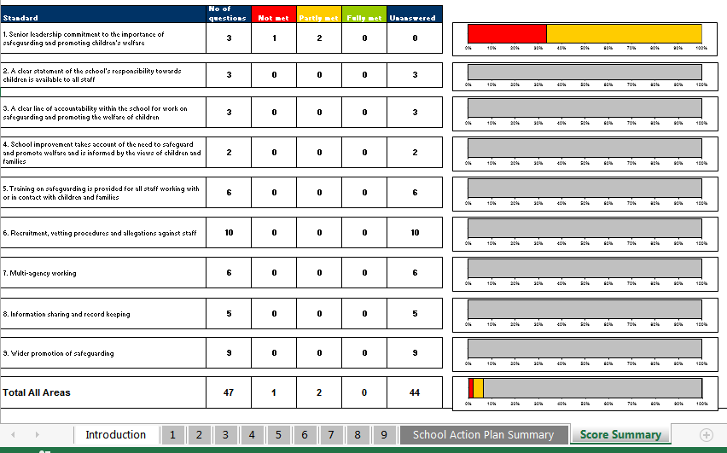

The score summary gives you a breakdown of how well your school is meeting the standards. For example, on this score summary, the school is not meeting 33% of the first standard and partially meeting 66% of the first standard.

- Once you have completed the audit, please ensure it is signed off by your Head Teacher / Academy Lead and send the electronic copy of the audit to sandra.reid@hackney.gov.uk.

